Monday, March 30th, 2020
The Nightclub on Display: A Look at Techno’s Influence on Art in 2019
By Celia Glastris

On the opening night of No Photos on the Dancefloor! Berlin 1989-Today, they said the line was longer to get into C/O Berlin than Berghain, the city’s most popular nightclub.

Inside, a photo and video exhibition on the history of techno culture from the fall of the Berlin Wall until today in the city unwound through a stark, Brutalist museum. Berlin’s nightclubs have always had a strict no photos policy, which meant the exhibition was an important survey for a culture that is rarely documented. For the same reason, it was also highly ironic. A culture that actively rejects documentation was on display for thousands to witness. Curator Heiko Hoffmann stressed he did not want the exhibition to be perceived as a “view through the keyhole.” Rather, “All the artists that I picked for the exhibition, they’re actually people of the community and part of the scene,” said the curator. “ So the reason why they could take the pictures or videos is because they knew the people who were running the parties, they were friends, or they knew the people running the clubs, and often they were the only ones that were allowed to take the photos in there.” Hoffmann even turned down a photograph from the iconic German photographer Andreas Gursky, known for taking photos of large masses of people at bird’s eye view, because the photo was from an outsider’s perspective. Making sure that the viewer felt like they were experiencing Berlin nightlife from within was one of the reasons that the final gallery in the exhibition was a full blown dance party. Big screens covered the walls showcasing the work of projection artists, and some of the city’s favorite DJs such as Modeselektor played.

Overnight, the well-regarded art foundation turned itself into a dance club. Young Berliners did ketamine in the bathroom, emerging with white powder still on their noses as they bumped into art professionals and collectors in town for Berlin Art Week, there to see the never-before-seen Wolfgang Tillmans photographs. Needless to say, the demographic varied extensively. Middle-aged couples who had experienced Berlin through the decades and people who just met made out on the dancefloor of Amerika Haus, the building that once held exhibitions by the likes of architect Frank Lloyd Wright and Postwar icon Robert Rauschenberg, with visitors such as John Steinbeck, Robert Kennedy, and Richard Nixon. That night was bound to add a new layer of history into its architecture.

No Photos on the Dancefloor wasn’t the only exhibition that put the nightclub on display in 2019. Several artists showed work that brought techno culture into the exhibition space.

In fact, one of the biggest hits at the Venice Biennale last year was influenced by techno. The Venice Biennale is a contemporary art festival on the Italian city that presents works of art from around the world every two years. It is widely understood to be the most important exhibition of its year, and countries typically put work forward that they consider to best represent their country, or towards the yearly prompt, which for 2019 was May You Live in Interesting Times.

Artist duo Pauline Baudry / Renate Lorenz represented Switzerland last year at the Venice Biennale. They turned the Swiss Pavilion into a nightclub for their video installation, Moving Backwards. Visitors entered the exhibit ‘through the backstage,’ first encountering a sequined curtain that intermittently moved to veil and unveil a stage with a video of five dancers of diverse backgrounds who experimented with backward movements in response to the “feeling of being pushed backward by recent reactionary backlashes.” The choreography blended ‘postmodern and urban dance’, which made the event seem both highly performative and authentic. It felt as if the party took place at once in an art institution and a queer underground space. Upon exiting the pavilion-nightclub, you entered an outdoor patio that looked like a bar and designated smoking area. On the wall was a letter written by Boudry and Lorenz as well as pamphlets on queer theory and resistance that visitors were welcome to take with them.

2019 was an eventful year for artist and musicologist Tony Cokes, who had eight solo exhibitions and screenings, including If Ur Reading This: It’s 2 Late: Vol I, which premiered at Goldsmiths Centre for Contemporary Art in London, the gallery of one of the city’s major art schools. The CCA spans three floors, with 700m² of exhibition space in eight distinct galleries. The massive exhibition included works made from 1990 until now, including two films made for the show.

In short, Cokes’ works are digital videos of typically appropriated text placed on bright color backgrounds that accompany music–– which is often techno. They vary based on size and site-specificity–– the artist molds the exhibition to have a social discourse with whichever city it is located in.

Leaving minimal intervention to the original architecture of the warehouse-style building, the upstairs galleries were turned into nightclubs reminiscent of the city’s rich history of techno and rave culture spanning back to the late 1980s. Cokes’ Goldsmiths exhibition made political statements with cross-Atlantic references. One room played, A Queen is Dead (2019), which was a biography on Aretha Franklin paired with House music. While techno and The Queen of Soul appear to be seemingly disparate, both the genre and musician were born in Detroit, Michigan, and integral parts of the vibrant history of Black music in Motor City. In A Queen is Dead, Cokes makes a point that techno music’s arrival in London is an export of Black culture, highlighting one of the countless contribution to music and pop culture that has roots in African American history.

Historically, rave parties actively were made private to provide spaces for marginalized groups to safely congregate and let loose. It’s paradoxical to see so many large-scale institutions make raves into exhibitions, since they’ve always defined themselves by their underground status. Exclusivity is definitive to rave culture, so much so that a rave on display isn’t really a rave at all. By implanting a rave into an exhibition space, the institution appropriates the role of being a safe space free from judgment, something which it certainly is not. However, without presenting these experiences they are lost from history due to their ephemerality. The artists who made these works come from diverse backgrounds, have experienced these parties, and are deservedly chronicling their histories by presenting them to an audience.

Perhaps the influx in exhibitions on techno and a desire to recreate rave nightlife is representative of its induction into a cultural hall of fame. Or put in other words, perhaps the movement is dead. It’s at least partly true. New York’s legendary club kids lost their momentum after mayor Rudi Giuliani came into office in 1994, and acid house parties were banned under Margaret Thatcher’s law enforcement in the 1990s, which changed the face of nightlife in both major metropolitan cities. It’s not gone, it’s just different.
In regard to the city of Berlin, Heiko Hoffmann adamantly was against this sentiment. “The subtitle [for No Photos on the Dancefloor] was 1989 to today. Why that is important for me is that I think the current club scene in Berlin has a lot of things happening that can be traced directly back to the beginnings. And I think that's a pretty unique situation.” He continues, “Of course when something has a 30-year-old history it becomes, as a whole, less in flux. But I can still hear things that really excite me and I think sounds and DJ sets that I hear are moving forwards into unexpected directions, so for me this is anything but dead.”
What’s most important is that it is understood where the rave tradition comes from. Each exhibition sheds light upon its roots, which are Black, queer, and inherently antifascist. Just between 2019 and 2020, the rave seems to have found a new format for use in the art world. Just last Saturday, March 28th, MoMA held a 24-hour rave online, called Come Together (Apart), with DJ sets that accompanied artist talks on the virus’s impact on the art economy, which is already embarking on an economic crisis as a result, and a meditation session to help those who were experiencing anxiety in light of COVID-19. With art fairs and openings all shut down at the moment, the art world has no form of congregation. It appears that the online rave may, instead of being put on display as a spectacle, actually have function this year for the art world.

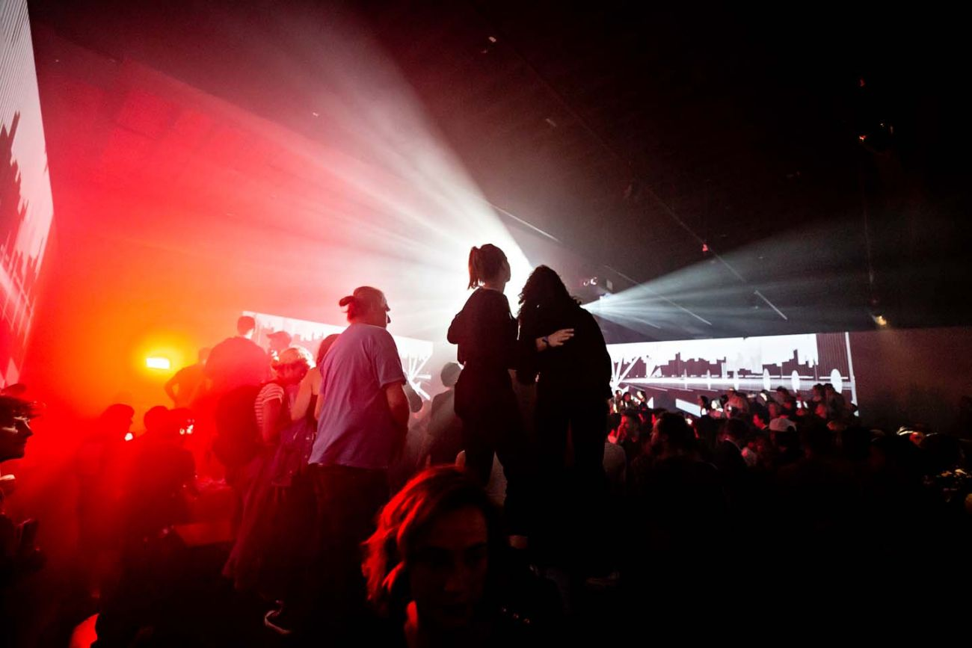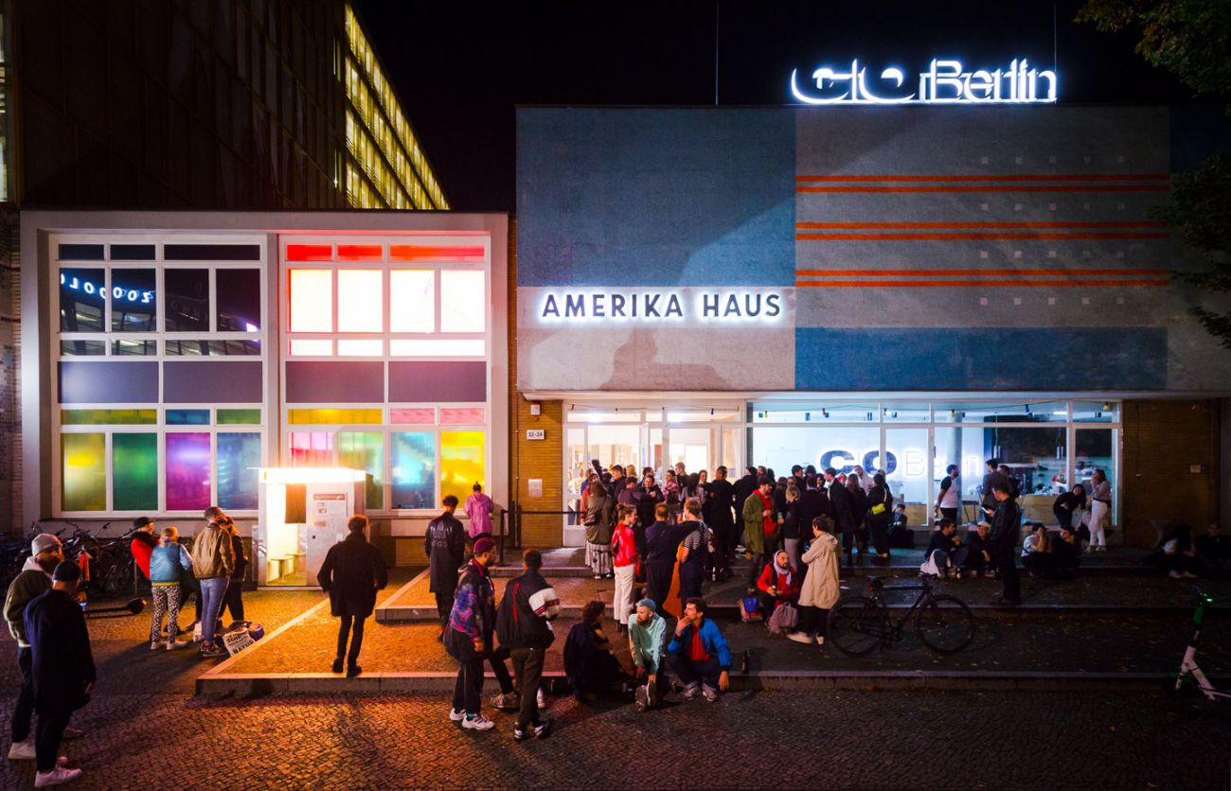
Images from opening night of No Photos on the Dancefloor: Berlin 1989-Today, courtesy C/O Berlin
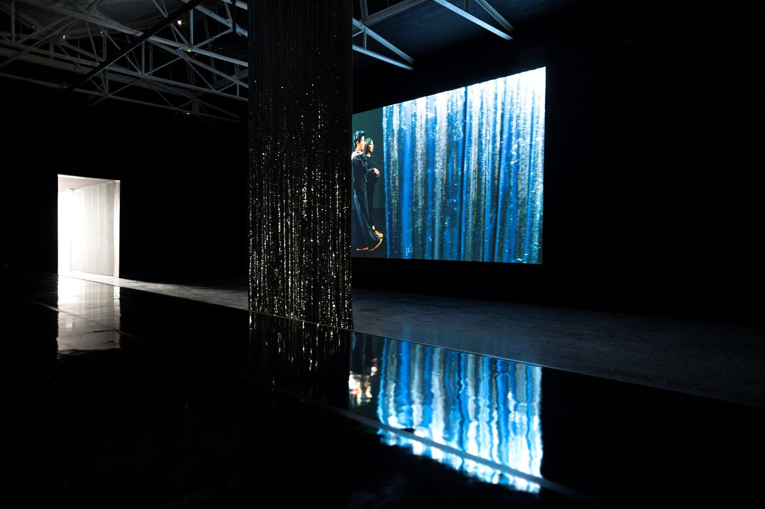
Inside Moving Backwards at the Venice Bienalle, 2019. Courtesy Swiss Pavilion.

.

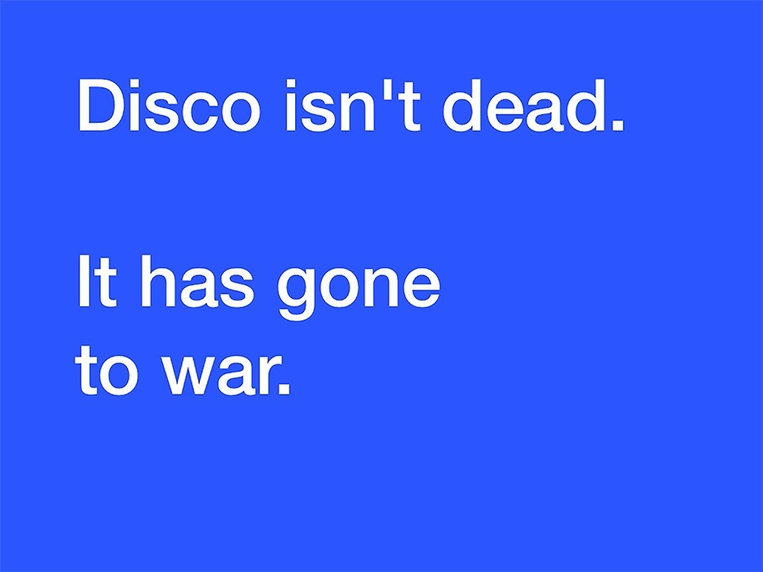
Tony Cokes, If Ur Reading This, It’s Too Late: Volume I, Goldsmiths CCA, 2019

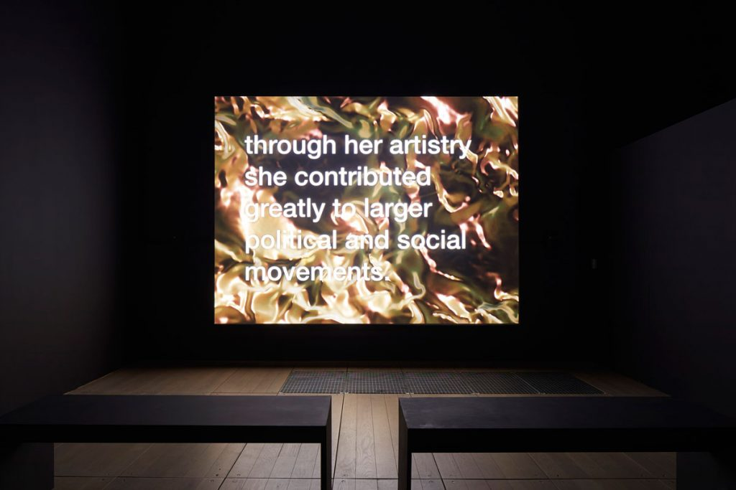
Tony Cokes, If UR Reading This It's 2 Late: Vol.1, “A Queen is Dead” (2019), Installation View, 2019. Goldsmiths CCA. Photo © Andy Stagg.

